Project Design Phase
Solution Architecture

Date | 17 February 2026
Team ID | LTVIP2026TMIDS78778
Project Name | Gemini Historical Artifact Description System
Maximum Marks | 4 Marks

Solution Architecture

1. Overview
The proposed solution follows a Cloud-Based 3-Tier Architecture that separates:
- Presentation Layer (User Interface)
- Application Layer (Business Logic & AI Processing)
- Data Layer (Database & Storage)
This architecture ensures scalability, performance, security, and maintainability.
2. High-Level Architecture Diagram
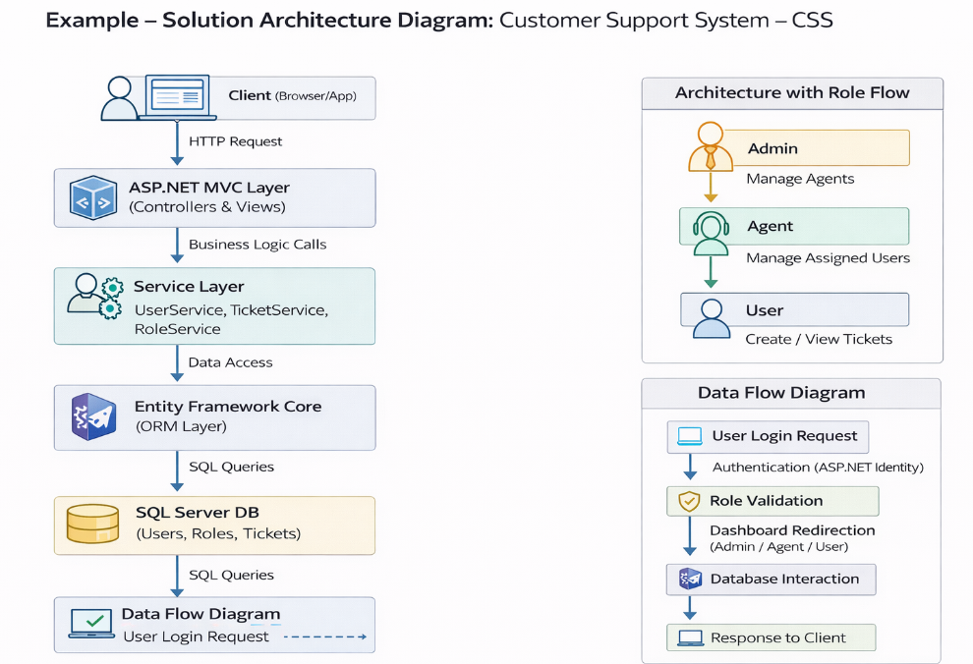

3. Architectural Components

A. Presentation Layer
Technology Used: Streamlit, HTML, CSS
Responsibilities:
- Accept artifact name input
- Accept word count selection
- Accept image upload
- Display generated description
- Show historical facts
- Provide regenerate option

B. Application Layer
Technology Used: Python
Sub-components:
- Input Processing Module
  - Validates user inputs
  - Handles image preprocessing
- Prompt Engineering Module
  - Structures prompt for AI model
  - Adds formatting instructions
- AI Integration Module
  - Sends request to Gemini API
  - Receives generated output
- Response Formatting Module
  - Organizes output into sections:
    - Origin
    - Time Period
    - Description
    - Historical Significance
    - Interesting Facts

C. AI / Machine Learning Layer
Model Used: Gemini 1.5 Flash (Multimodal AI)
Capabilities:
- Text-based generation
- Image-based artifact understanding
- Contextual historical explanation
- Structured content generation

D. Data Layer
- User Database (SQLite / Cloud DB)
  - User credentials
  - Login information
- Description History Storage
  - Previously generated artifact descriptions
- Image Storage
  - Uploaded artifact images

4. Data Flow Explanation
- User enters artifact name or uploads image.
- Frontend sends request to backend.
- Backend validates input and prepares AI prompt.
- Request is sent to Gemini API.
- AI model generates structured description.
- Backend formats response.
- Output is displayed to user.
- Optional: Data is stored in database.

5. Architectural Characteristics
Cloud-Based Deployment
API-Driven AI Integration
Modular Design
Scalable Infrastructure
Secure Communication (HTTPS)
Separation of Concerns (3-Tier Model)

6. Development Phases
Phase 1: UI Development
Phase 2: Backend Logic Implementation
Phase 3: AI Integration
Phase 4: Database Integration
Phase 5: Testing & Deployment

7. Why This Architecture is Suitable
- Supports multimodal AI processing
- Easily scalable with cloud deployment
- Secure API communication
- Modular and maintainable
- High performance for real-time AI generation

